***COLLEGE OF BUSINESS AND ECONOMICS***



**SCHOOL OF BUSINESS PROGRAM: BIT 2 (HUYE CAMPUS)**

**MODULE: MULTIMEDIA TECHNOLOGY**

**ASSIGNMENT**

**NAME: UMURERWA MIREILLE**

**REG NO:220013685**

**GROUP 2**

1. a) Create a collage in adobe Photoshop:

Pick five different images

-The first picture is your own picture

-The second picture is the Caucasus Mountains

-The third picture is the Blue flowers

-The fourth picture is the Baku City

-The fifth picture is the Caspian Sea

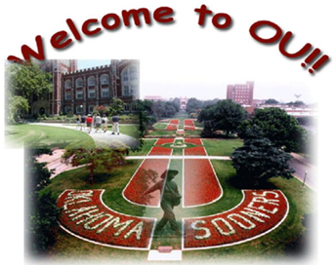

After the collage you will write the two sentences in the picture, one in the top: WELCOME TO BAKU and another in the bottom: CAUCASUS MOUNTAINS.

**ANSWER**

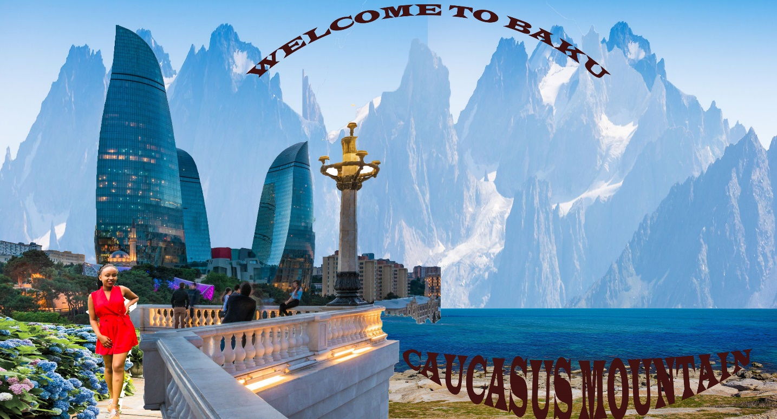

b) The following picture shows the example of an image of the final composition

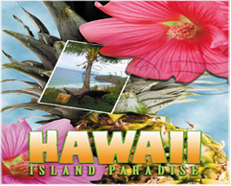

Pick four different images

-The first picture is papaya fruit

-The second picture is the Tiber River

-The third picture is the Mediterranean Sea

The fourth picture is the Green Stamp

Based on the image above you compose such an image and then write a text at the bottom

TIBER RIVER

THE LONGEST RIVER IN ROME

**ANSWER**

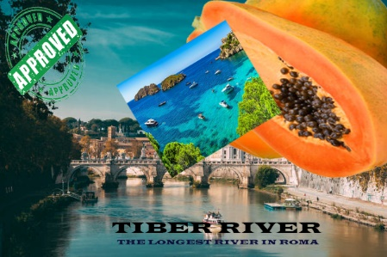

c) In the following picture use any techniques you want to remove the stones from the picture and replace them by the grasses and flowers.

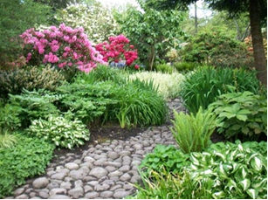

**ANSWER**

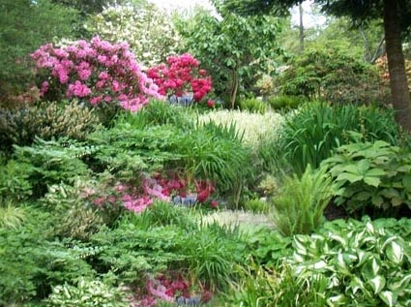

d) Pick a picture of Lake Baikal and use techniques of your choice to increase the area of the lake.

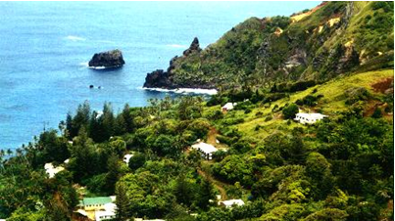

**ANSWER**

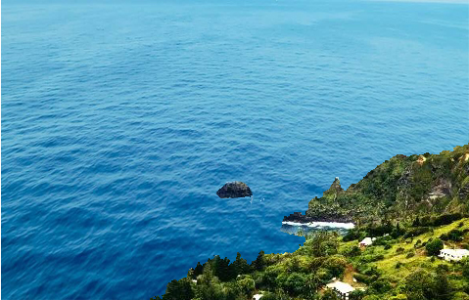

e) Pick a picture of Zamalek Team

-Show different effects of motion blurring, Gaussian blurring

motion blurring



Gaussian blurring

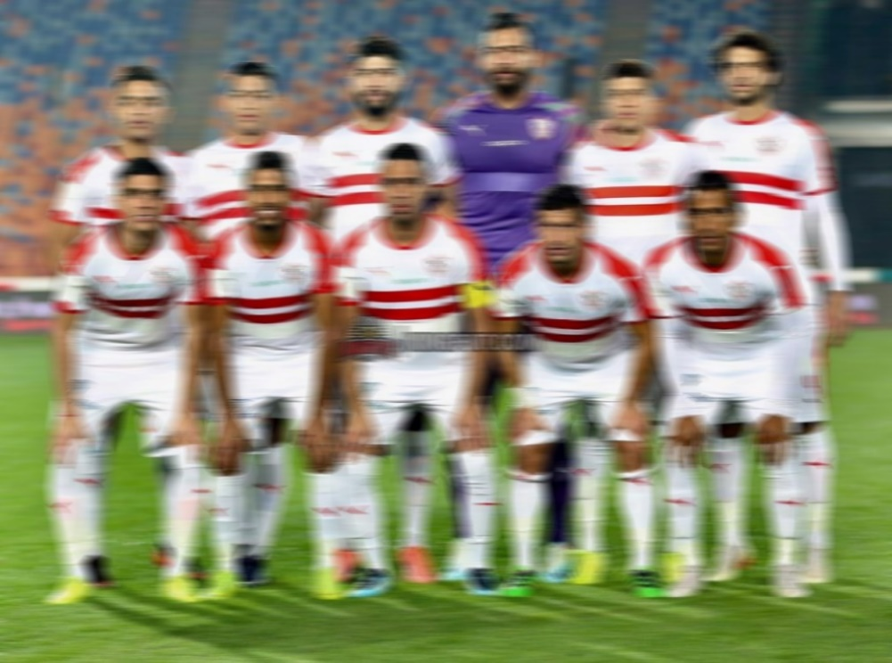

-Show the effects of increasing the brightness, sharpening edges, adding noise

the brightness



sharpening edges



adding noise



-Create the sepia tone effects



f) In the following picture use different techniques to remove the scar and tattoo from the face and skin.

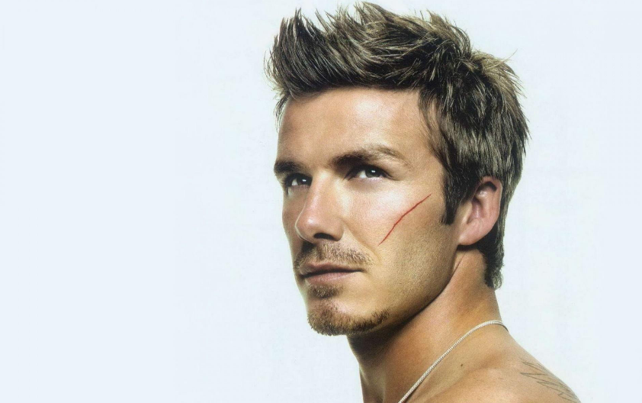

**ANSWER**

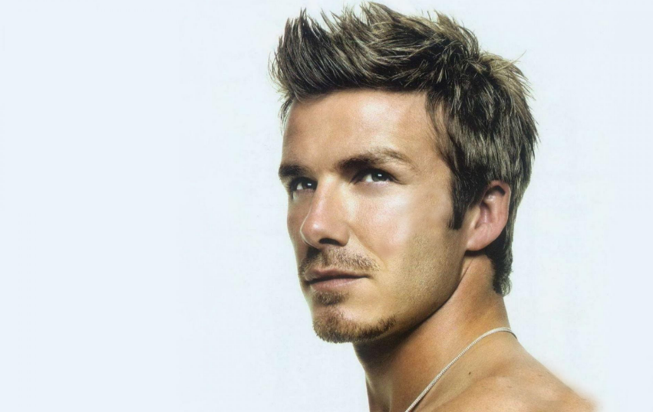

2. a) Pick your own picture,

-create both paint and classic effects

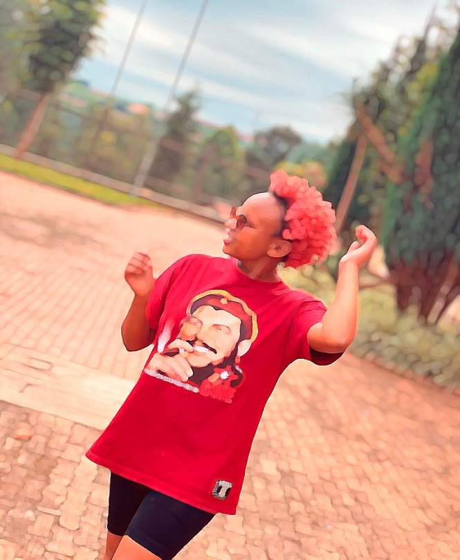

-create a realistic coin

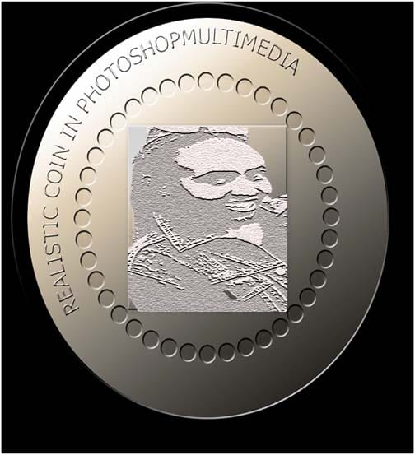

-create a pencil photo sketch

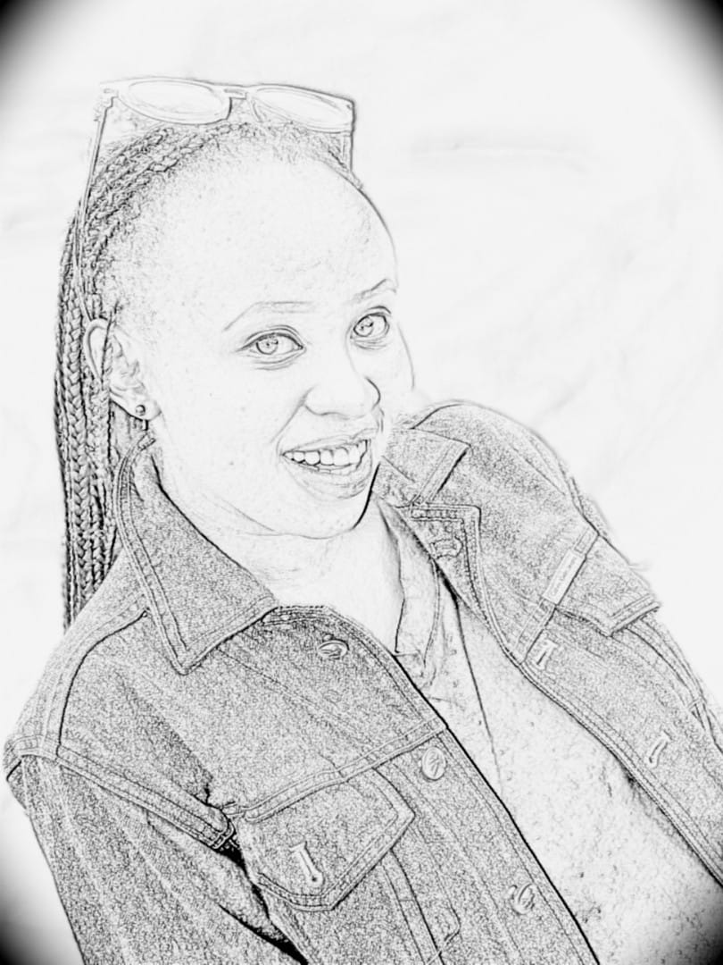

-create dispersion effects

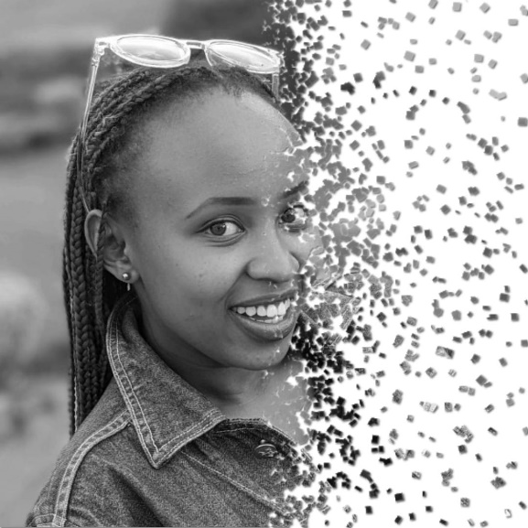

-perform cover art

-add sepia tone effects

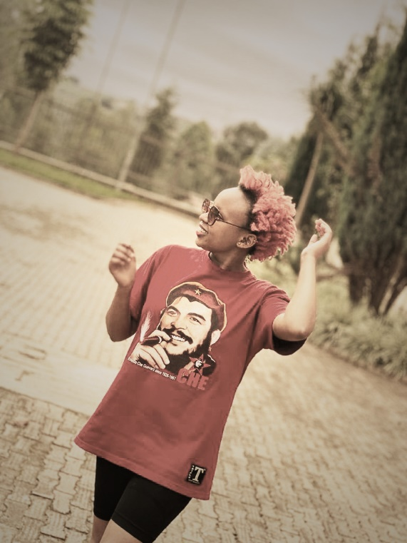

-add soft focus effects

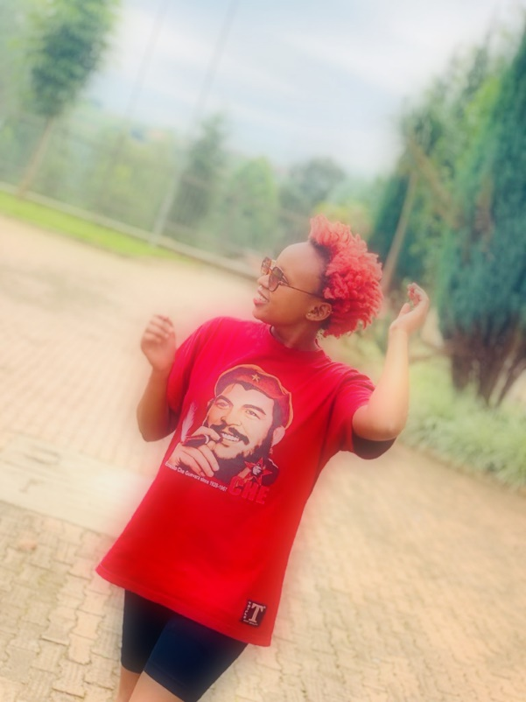

-add dragan effects

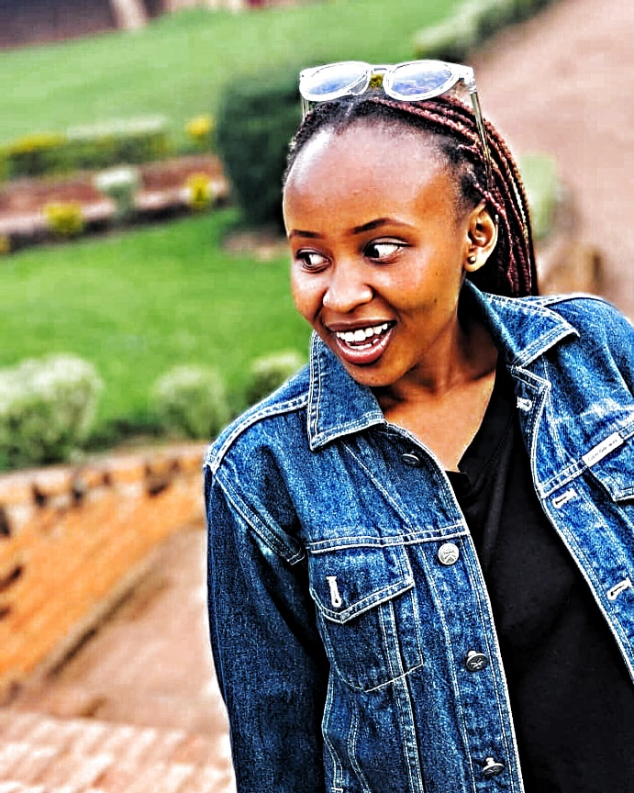

-add borders to a photo

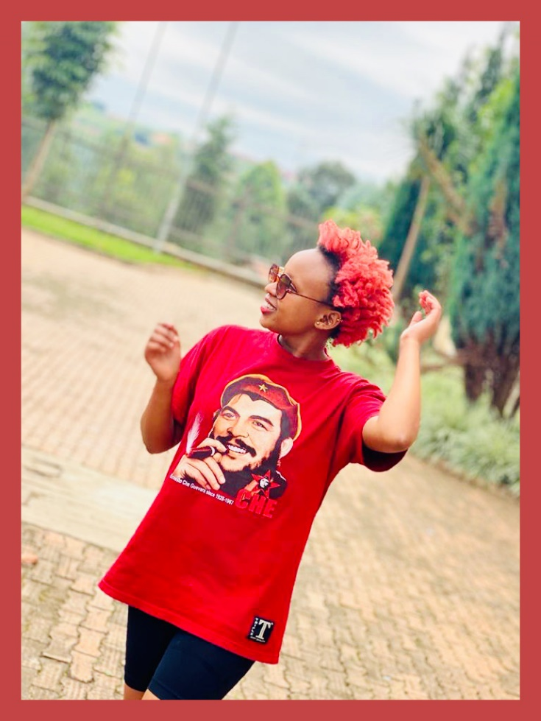

-add skin tone effects

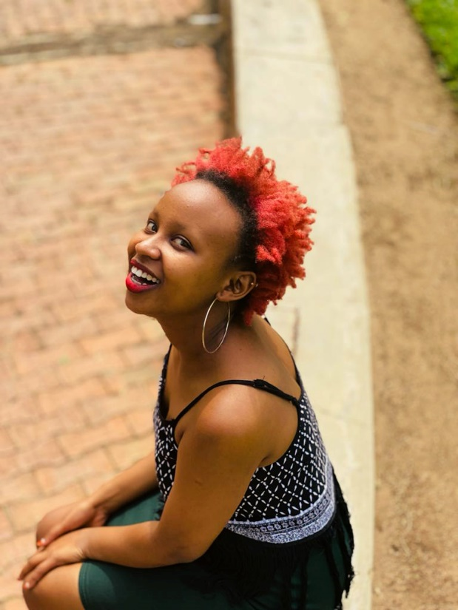

-create blurry glass effects

-create frosted glass effects

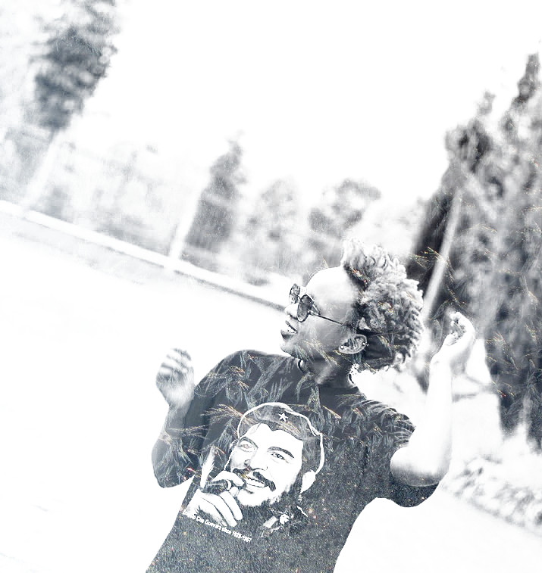

b) Pick a picture of Dolomites Mountains

-create a scenic sunset

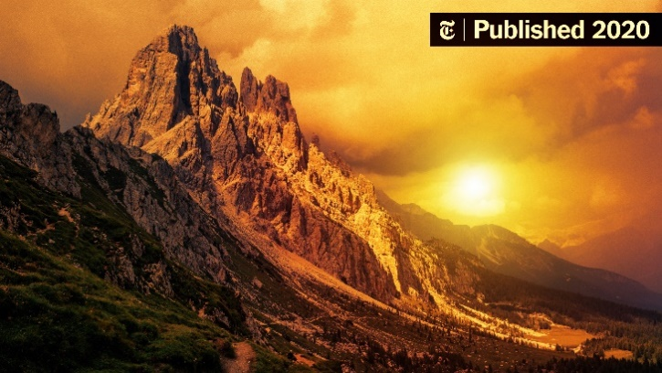

-create a scenic sunrise

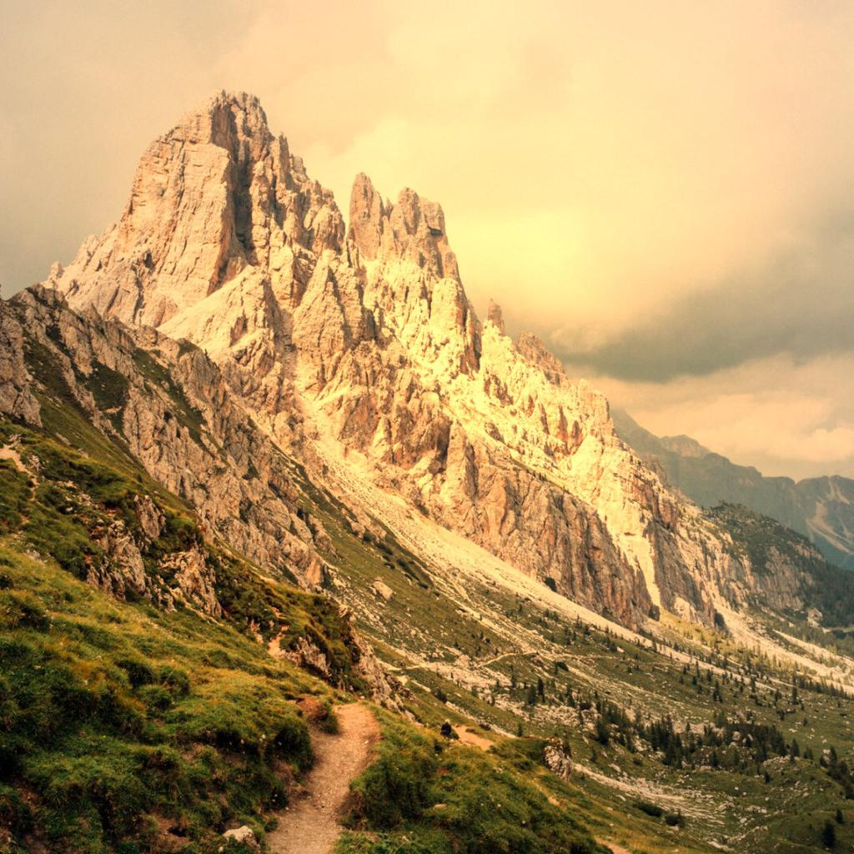

-create flood scene

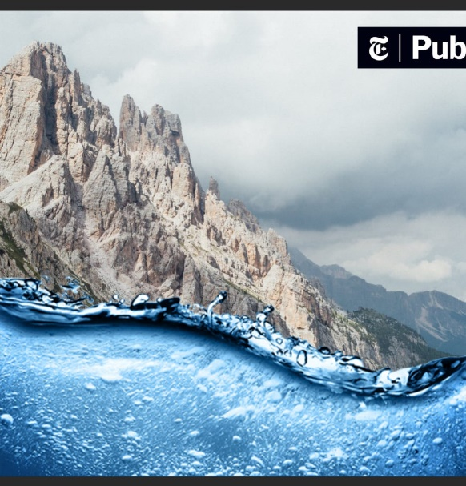

-add summer effects

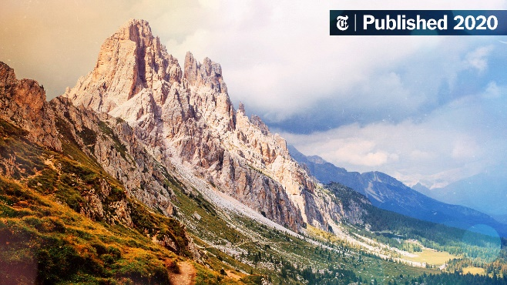

-add winter effects

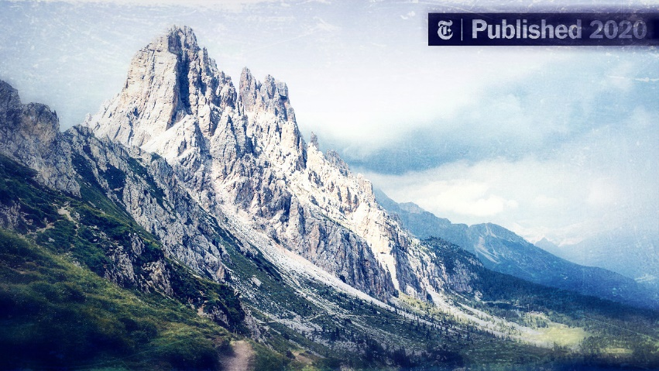

-add snow effects

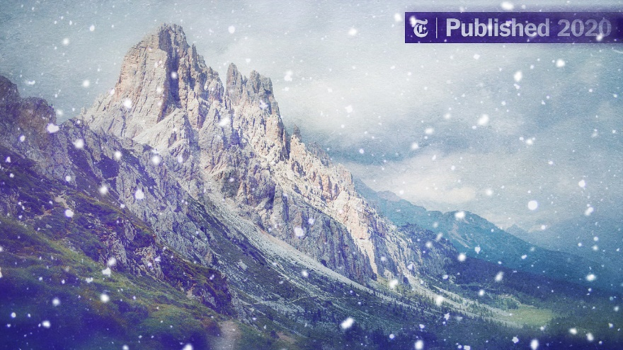

-add rain effects

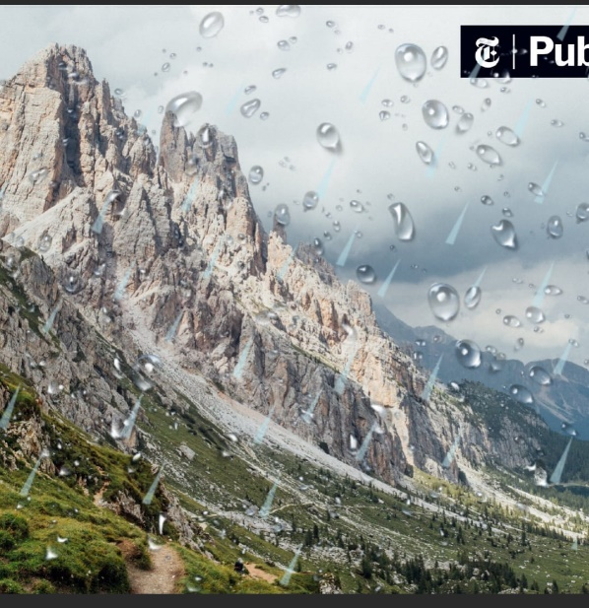

-add thunder effects

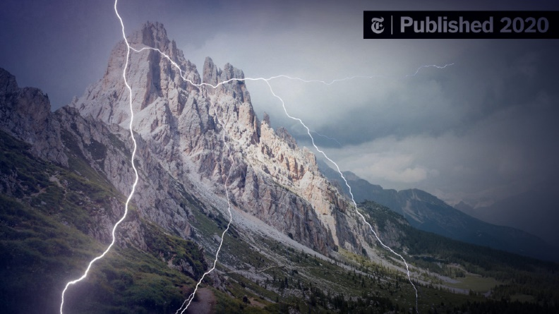

-add storm effects

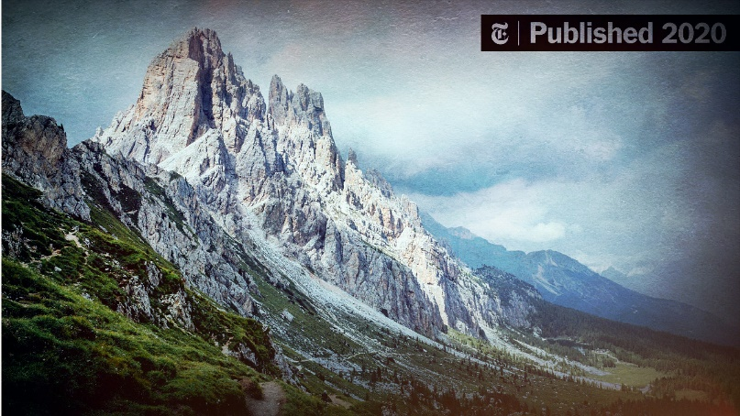

-add realistic water drop to a photo

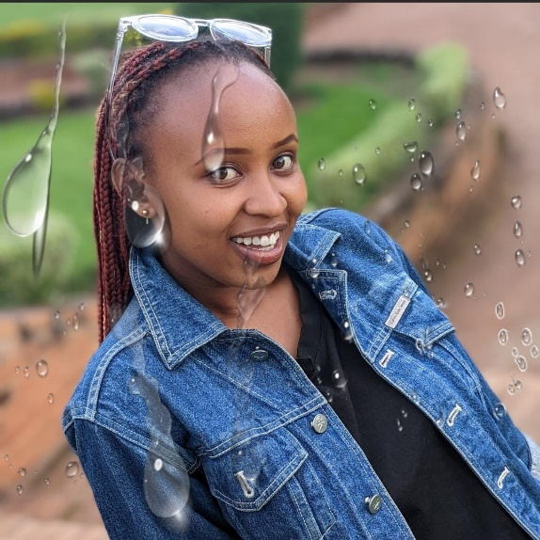

-create a mysterious forest scene

-add warm atmosphere effect to a forest

-make a realistic shadow

c) Pick a picture of Rusumo Falls

-create silky smooth waterfall

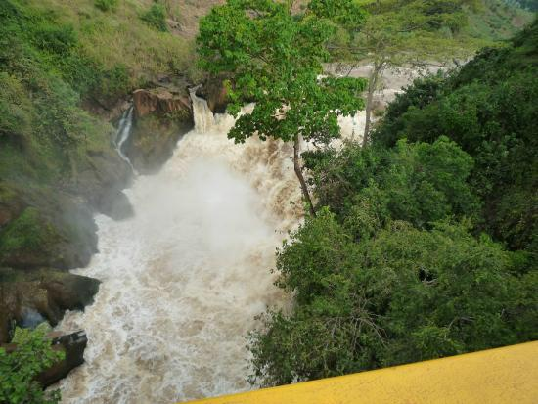

d) Pick a picture of Steffi Graf

-make a fire text effects in picture (names)

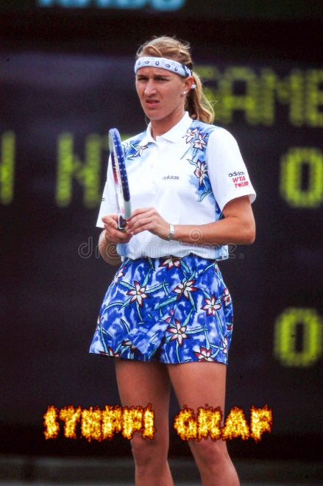

-add broken effects

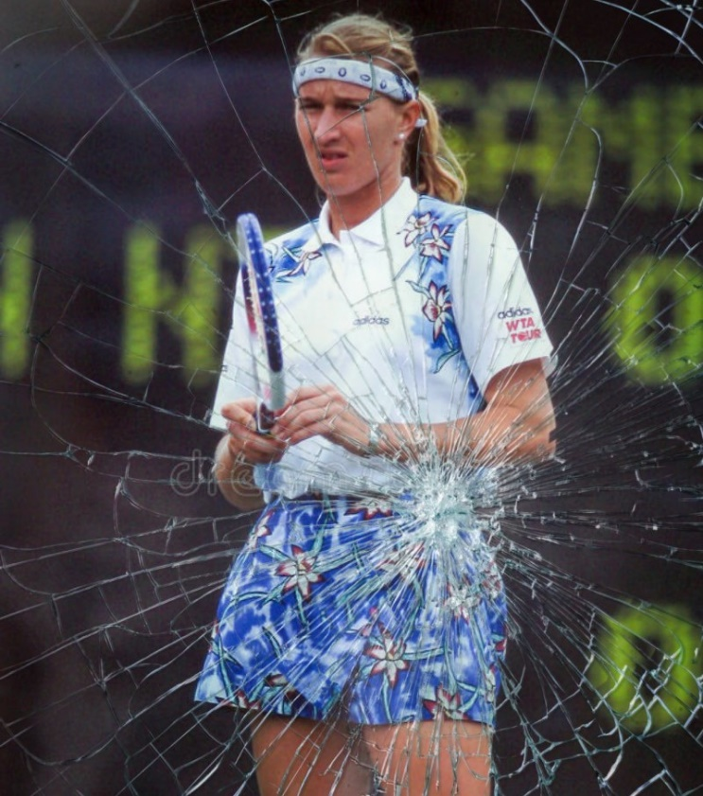

-create smoke bomb overlays

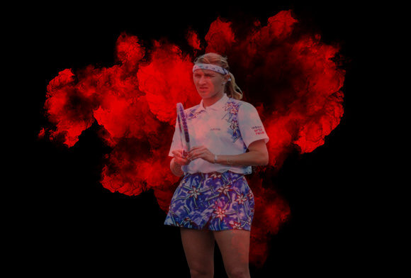

-create ashes and embers dispersion action

-add sand storm effects

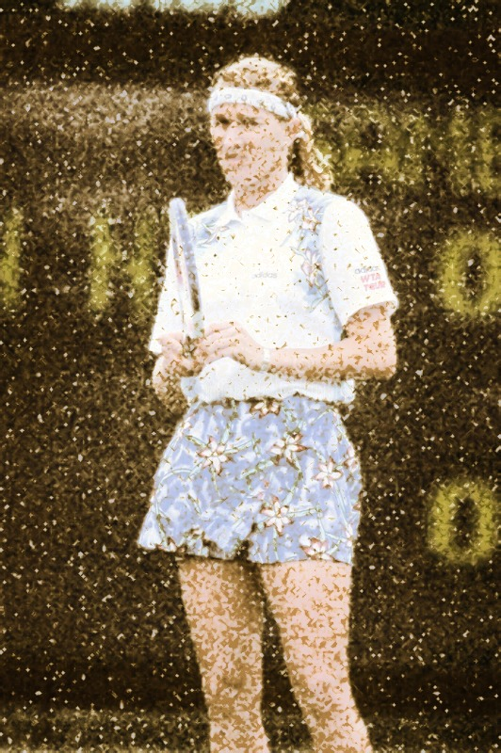

-add shatter effects

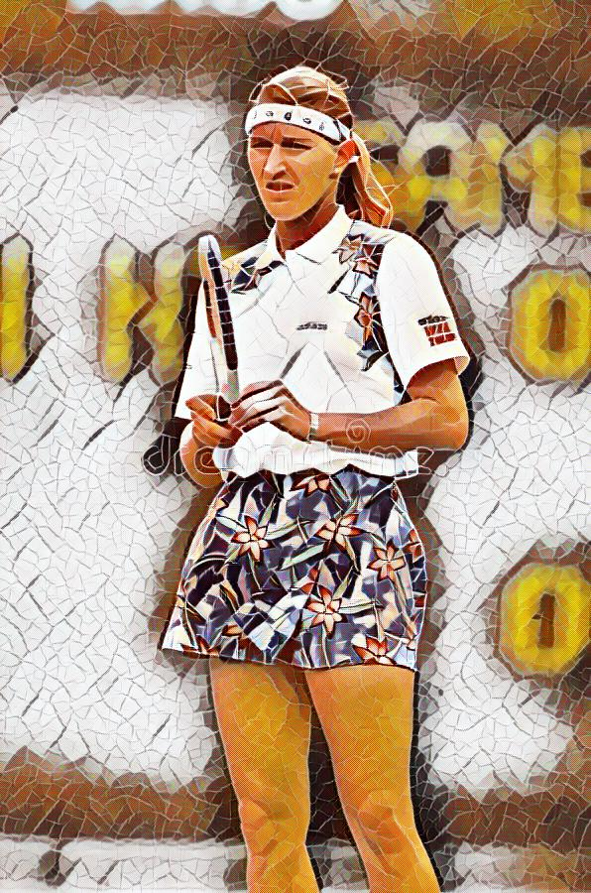

-add fragment effects

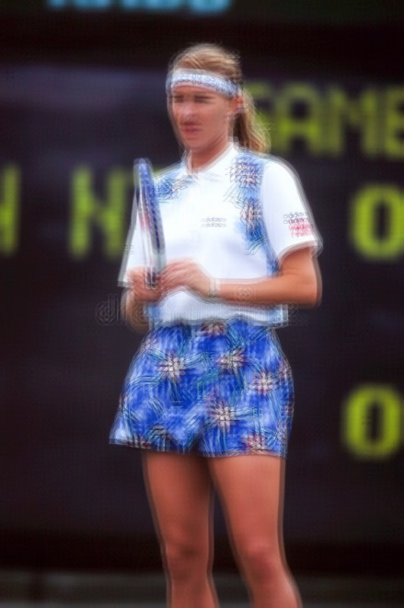

-add forge effects

-add double exposure effects

-add portal effects

3. a) Pick a picture of Hamburg City

-Create a reflected image

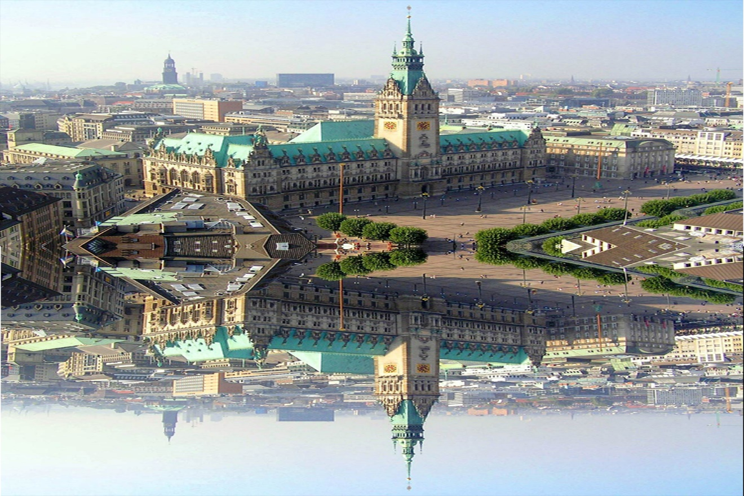

-Create a mirrored image

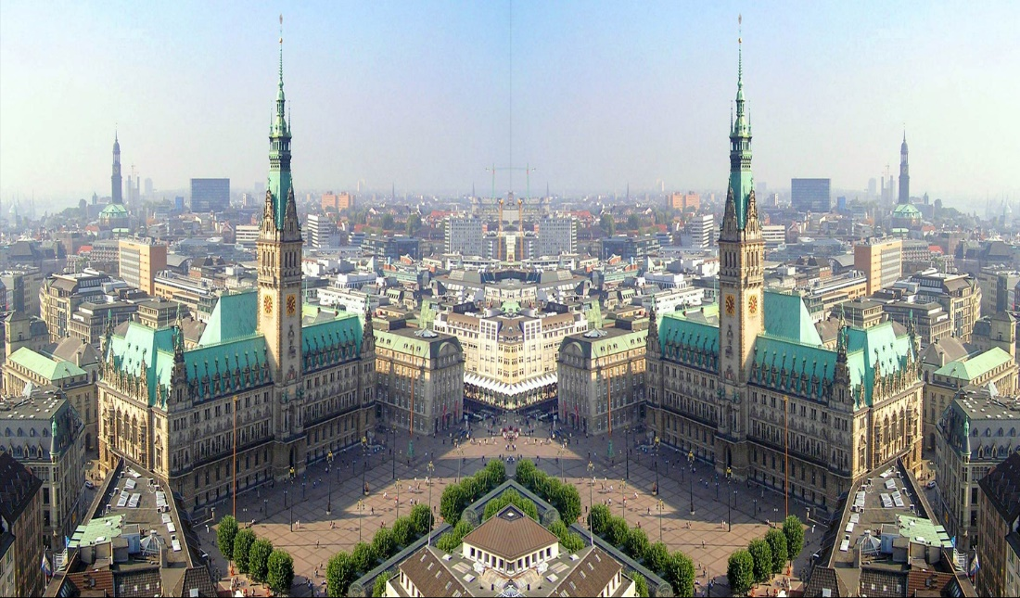

-Select a part of that picture and put it the:

* Four corners of the reflected image

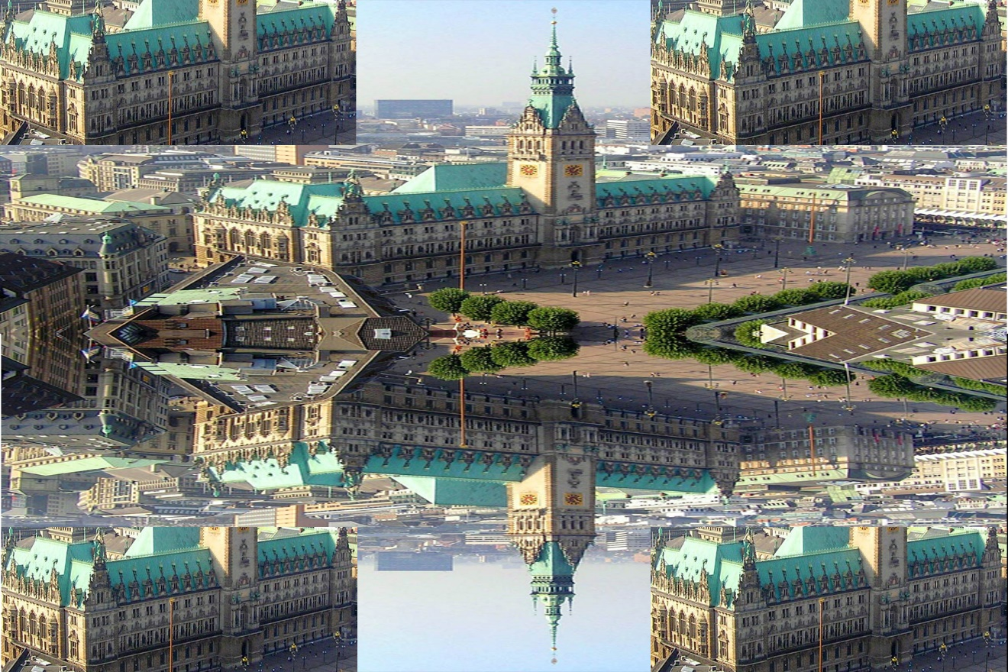

* Four corners of the mirrored image

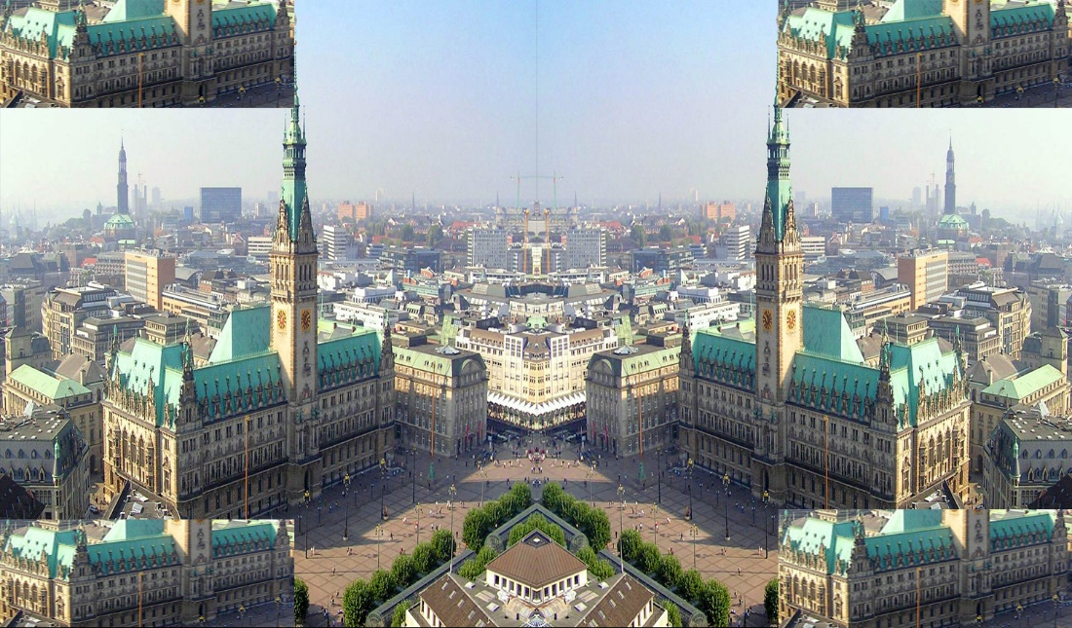

b) Pick a picture of Angkor Wat

-Create a water reflexion of the original image (Vertical)

-Create a water mirror of the original image (Horizontal)

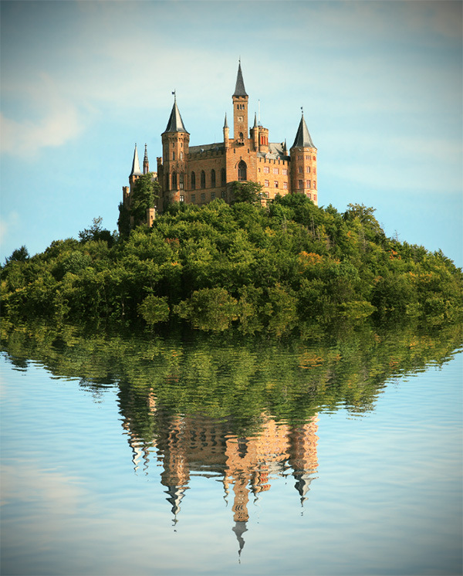

**ANSWER**

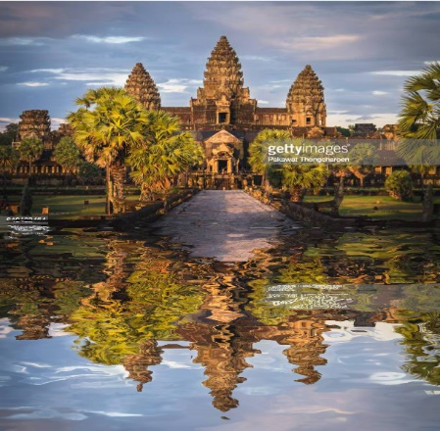

c) Create both the vertical and horizontal water reflexions of the Historical Site of Petra picture

vertical

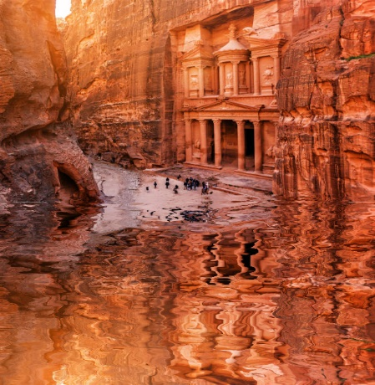

horizontal

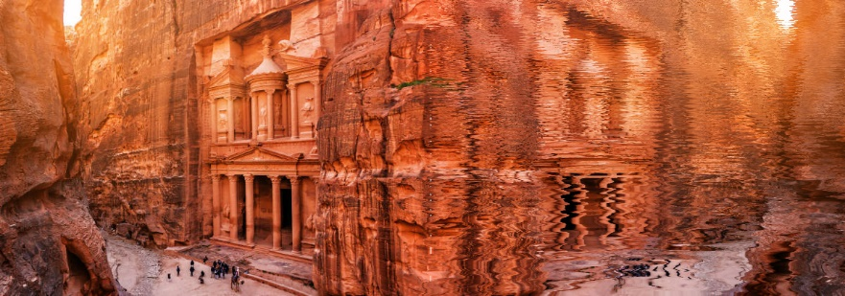

d) Create both the vertical and horizontal water reflexions of the following pictures:

-Indian Army Parade

vertical

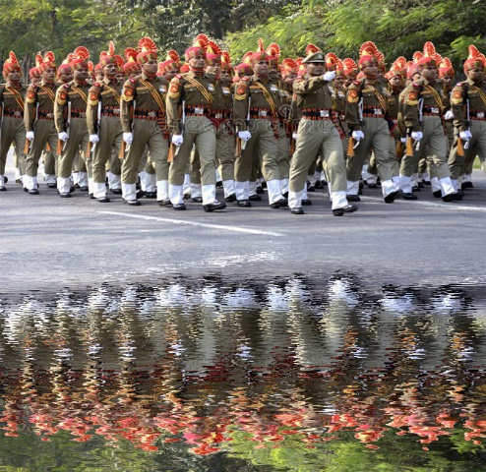

horizontal

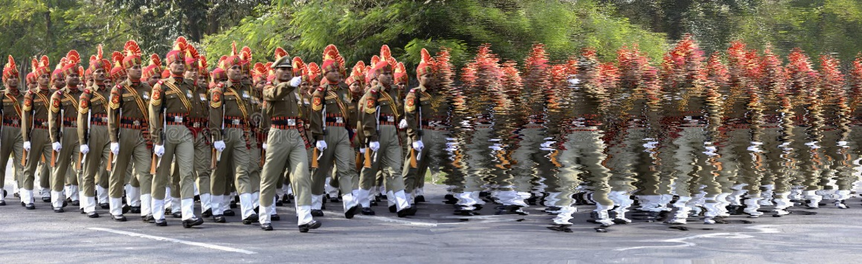

-Fabio Grosso

vertical horizontal

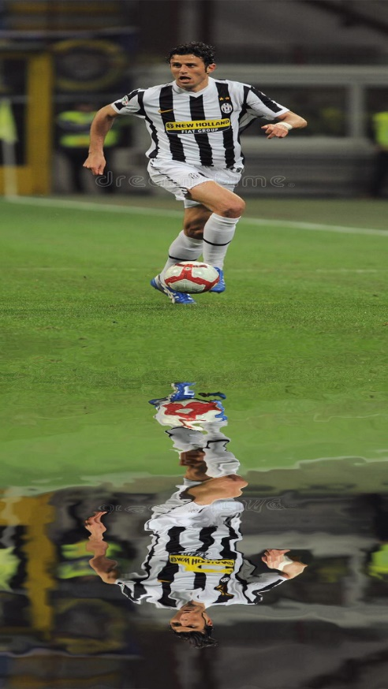 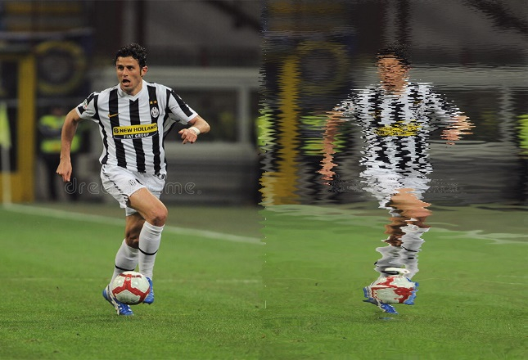

5. a) Pick a picture of a volleyball team Panasonic Panthers

-create a text PANASONIC PANTHERS with a photo (Photo Filled Text)

## 

## -create a warped text

**ANSWER**

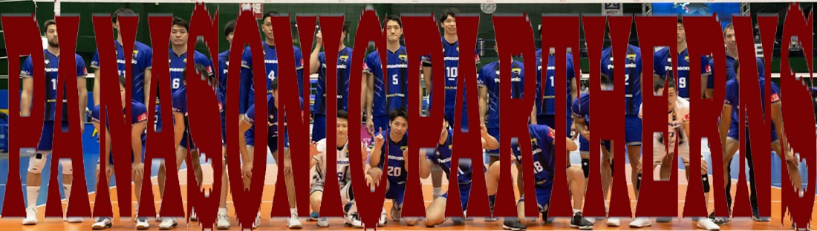

b) Pick a picture of the Colosseum, create a 3D of the original image

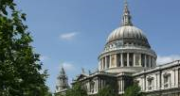

**ANSWER**

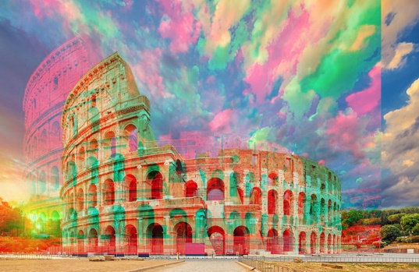

c) Create a simple 3D Text Effect of the following: ANGKOR WAT

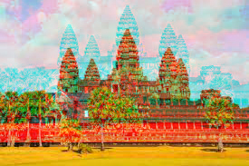

d) Pick a flag of Nepal and make a rippling flag

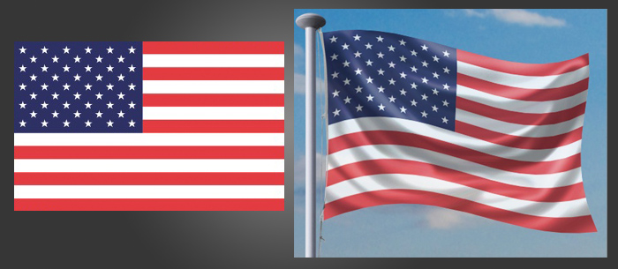

a flag of Nepal

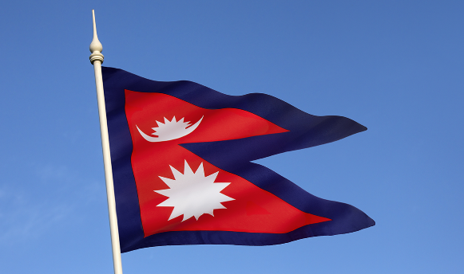

**ANSWER**

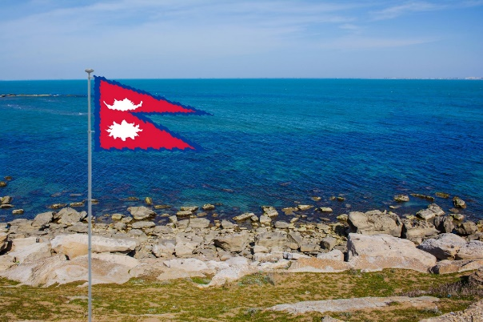

e) Pick your own picture, create a vignette (white and transparent background) with borders

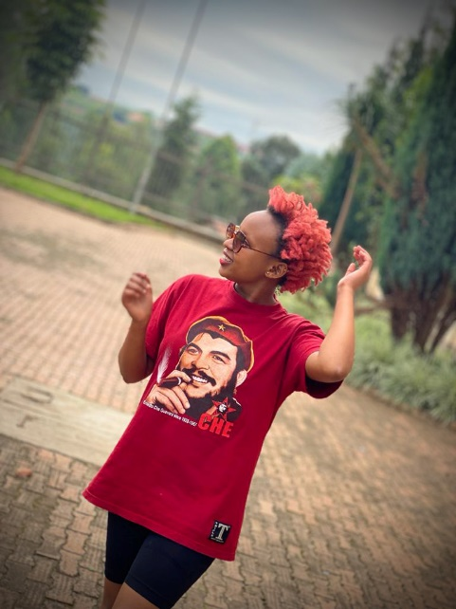

f) Create a Dark-Edged Vignette Effect in Apeldoorn Volleyball Club

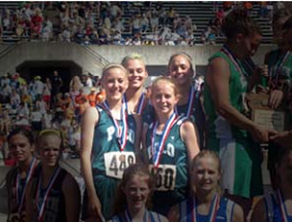

**ANSWER**

**BEFORE**

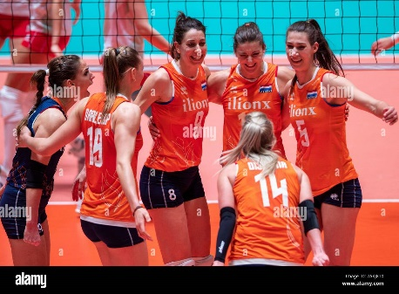

**&& AFTER**

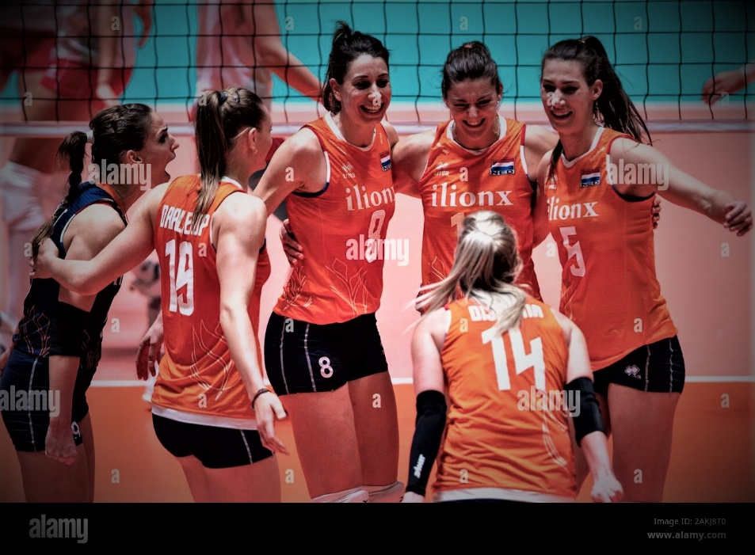

g) Create vintage photo effects of Toronto City

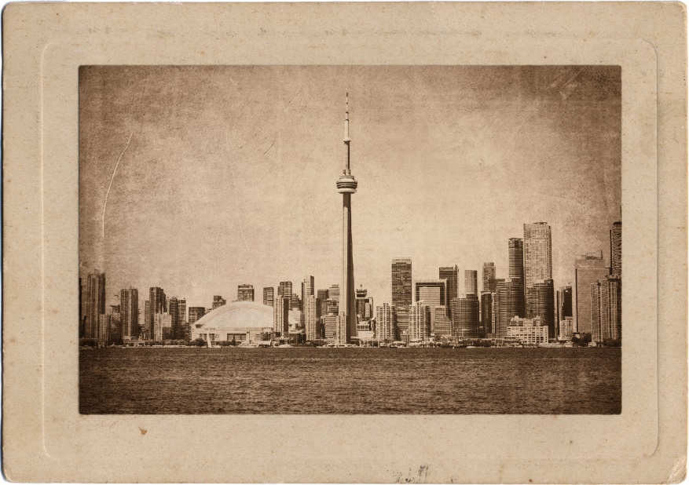

h) Pick a picture of a blue car and make it yellow

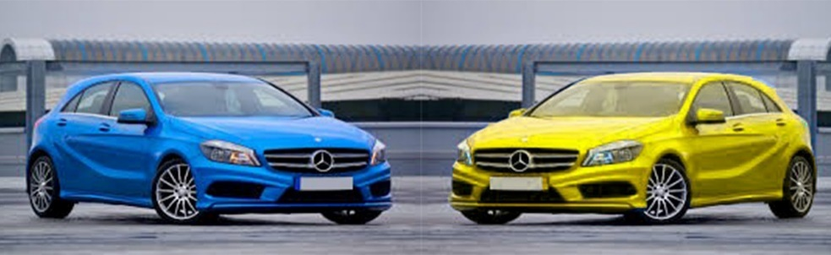

i) Pick a picture of blond-haired person and make it black

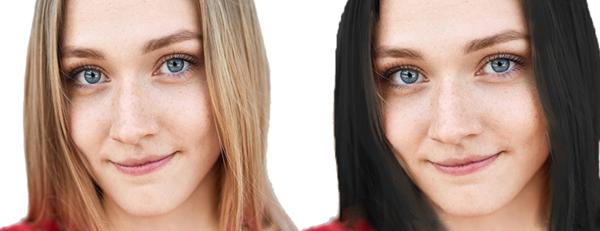

j) Pick a picture of a blue-eyed person and make them black

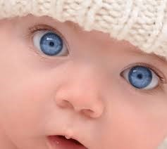 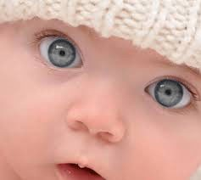

k) Pick a picture of a person with yellow teeth and make them white

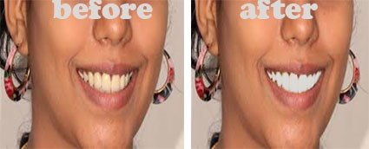

6. a) Improve the following underexposed photo

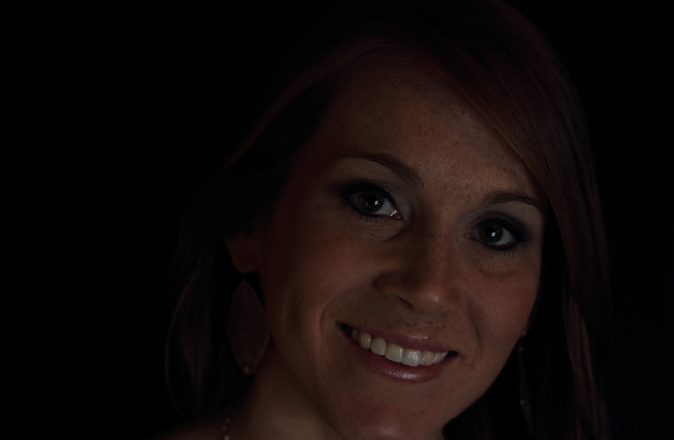

**ANSWER**

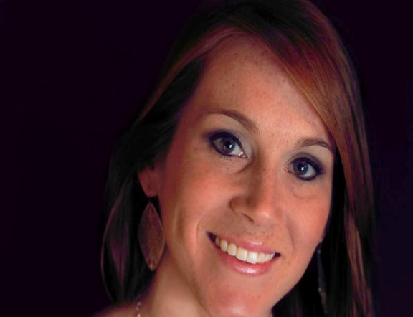

b) Improve the following overexposed photo

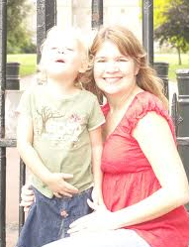

**ANSWER**

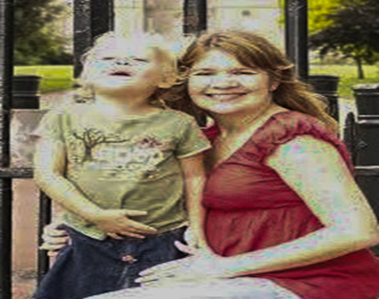

c) Remove the colorcast in the following photo

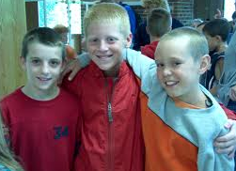

**ANSWER**

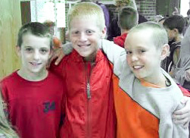

d) Colorize the following black and white photo

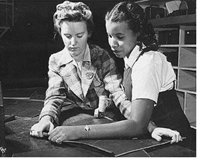

**ANSWER**

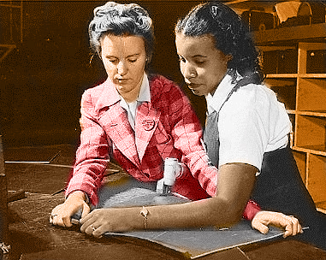

e) Restore the following damaged photo(Give both colored and black and white photos)

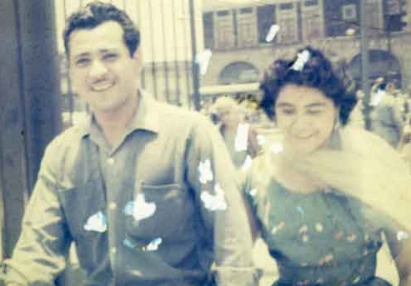

**ANSWER**

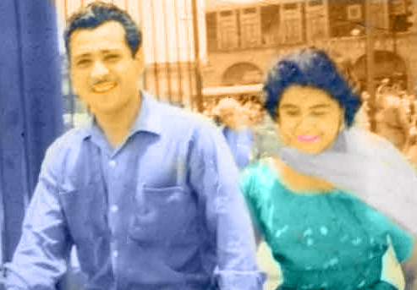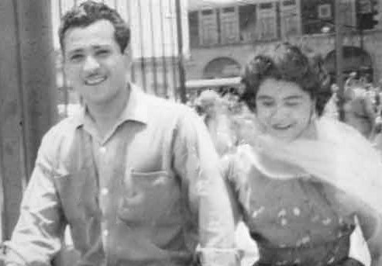

f) Restore the following old photo(Give both colored and black and white photos)

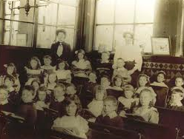

7. a) Pick a picture of Carlo Ancelotti and use any techniques to remove his name and his number from the picture.

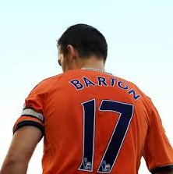

**ANSWER**

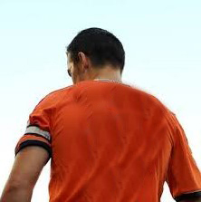

b) Pick a picture of an Irish father and his daughter, make a montage so that they look like below

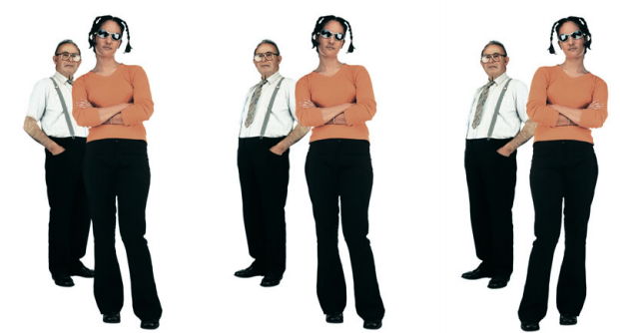

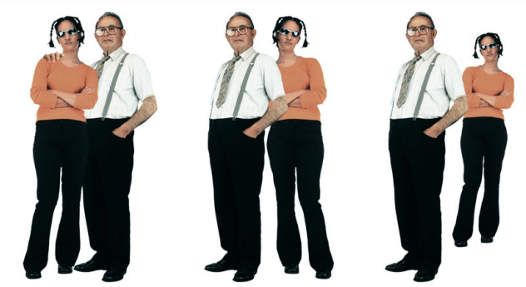

**ANSWER**

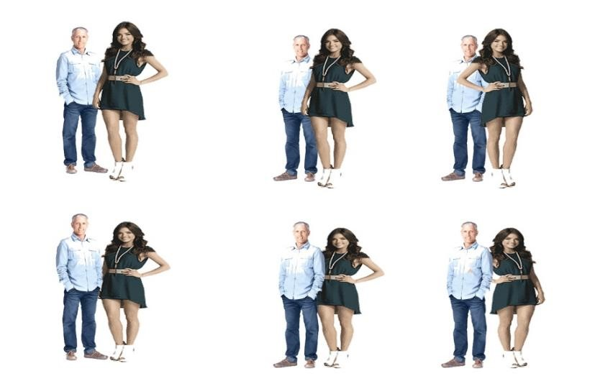

c) This picture shows a person who is located in front of the fence and he is moved behind the fence.

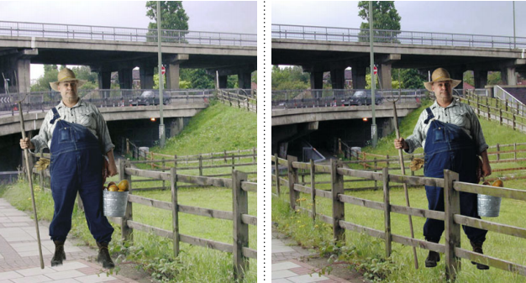

**ANSWER**

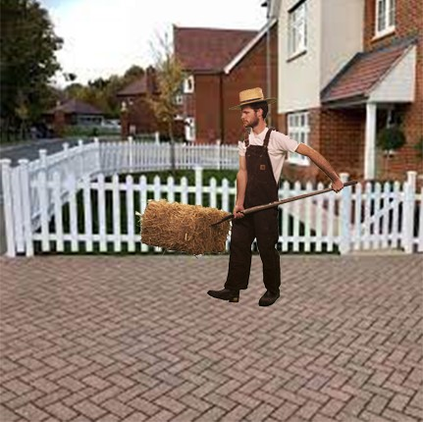 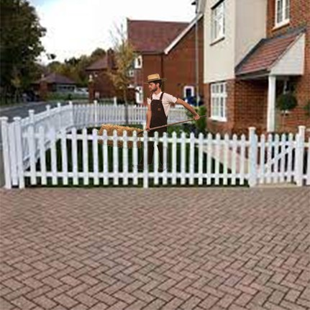

d) Pick a picture of a person and make a shadow on wall and ground

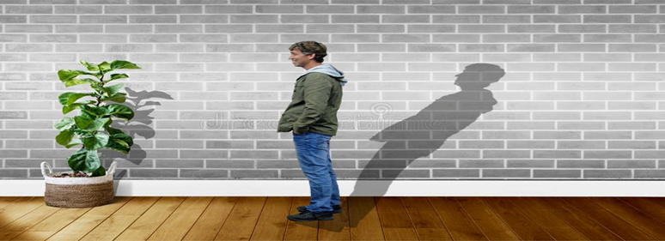

e) Pick a picture of the Forbidden City and create an artificial lake near it with six wild turkeys flowing over water.

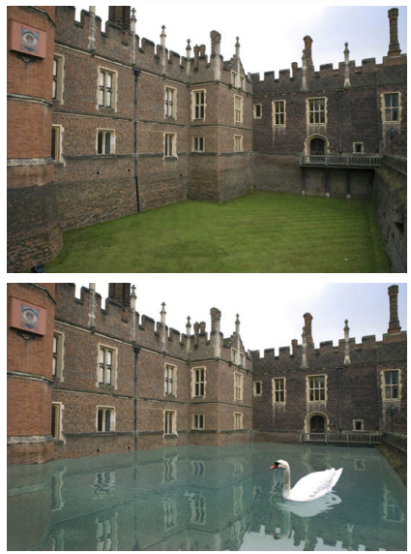

**ANSWER**

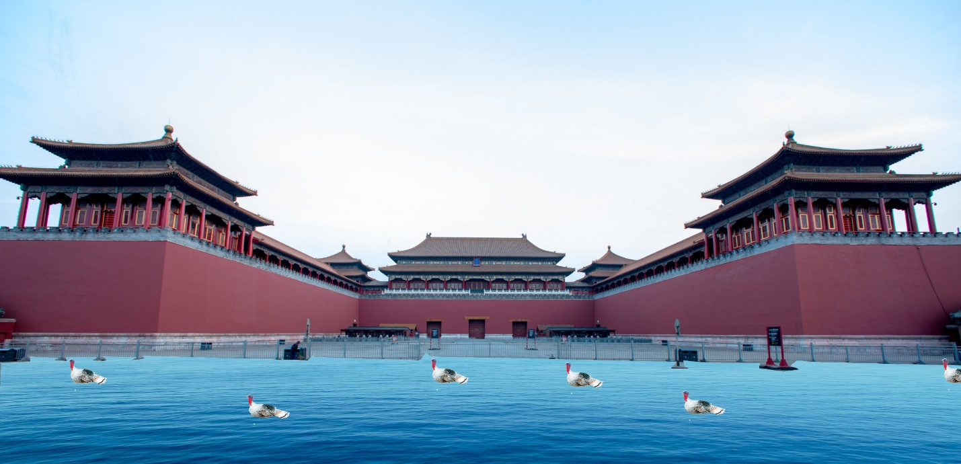

f) Pick a picture of the Machu Picchu and turn day into night

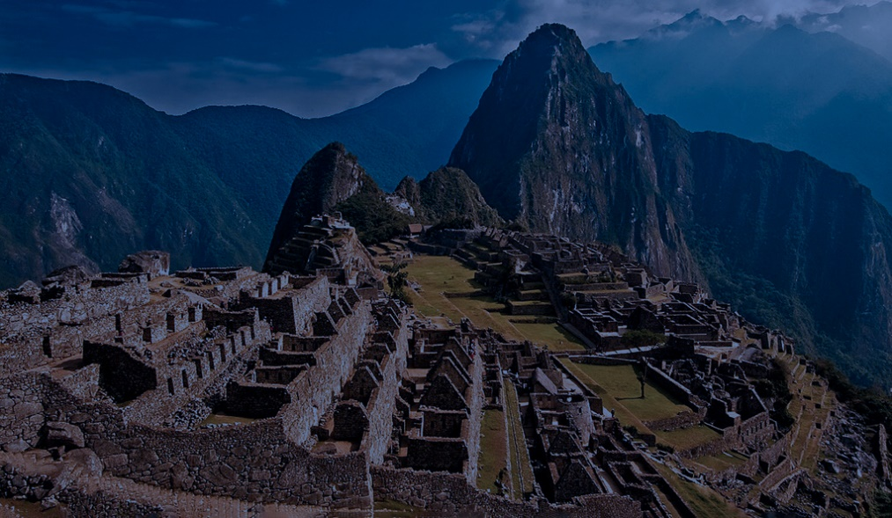

g) The pictures below show a hotel with its pool, a car, the final picture shows a car submerged in water.

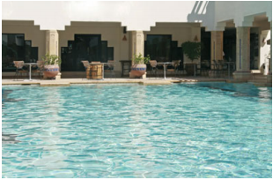

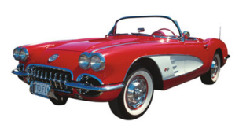

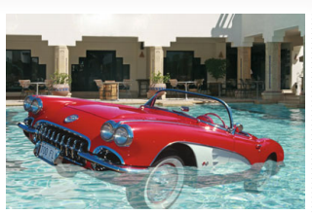

Pick a picture of a Chinese hotel, a bicycle and place a bicycle in water and make it appear partially submerged in water.

g) Pick a picture of Celine Dion, Frederic Francois, Don Williams, Phil Collins, Michel Sardou, ABBA band, make a Photoshop montage.

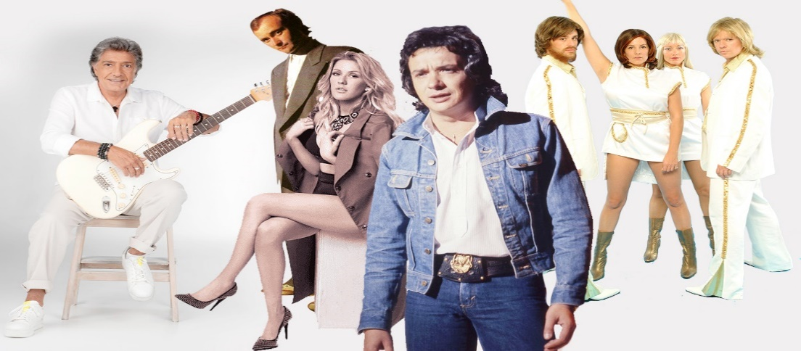

hs) Pick two pictures: Celine Dion and Acropolis of Athens. Use Photoshop techniques to put him in front of Acropolis of Athens

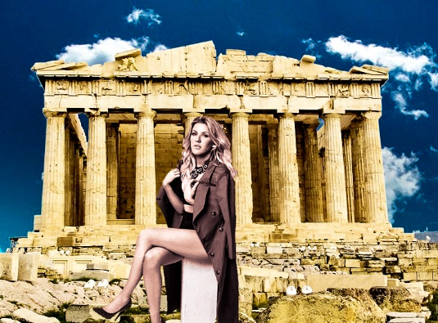

i) The cloning techniques are used to produce the pictures below:

a) Security guard

 

b) Spiral of flowers

 

Pick a picture of Diego Godin and calla lily flower, perform the same as in a and in b, respectively.

**ANSWER**

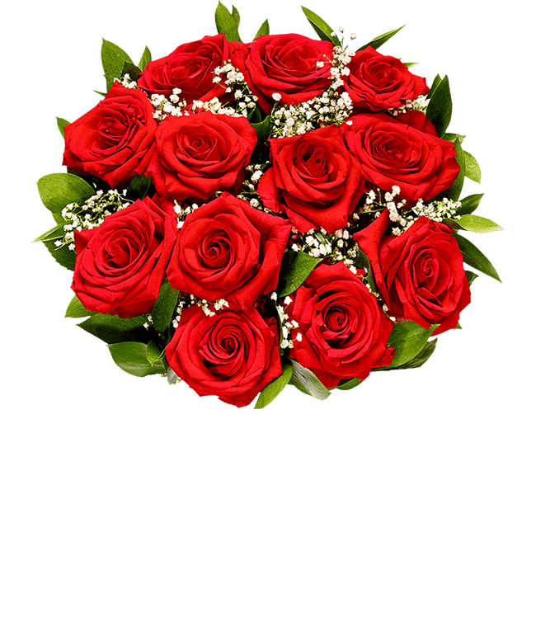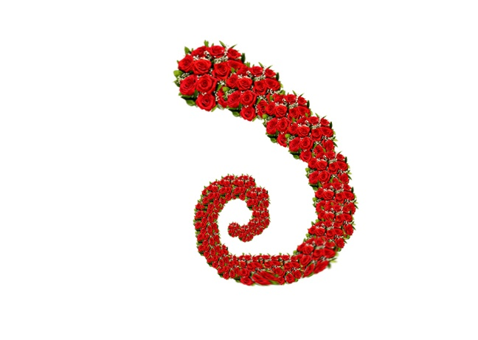

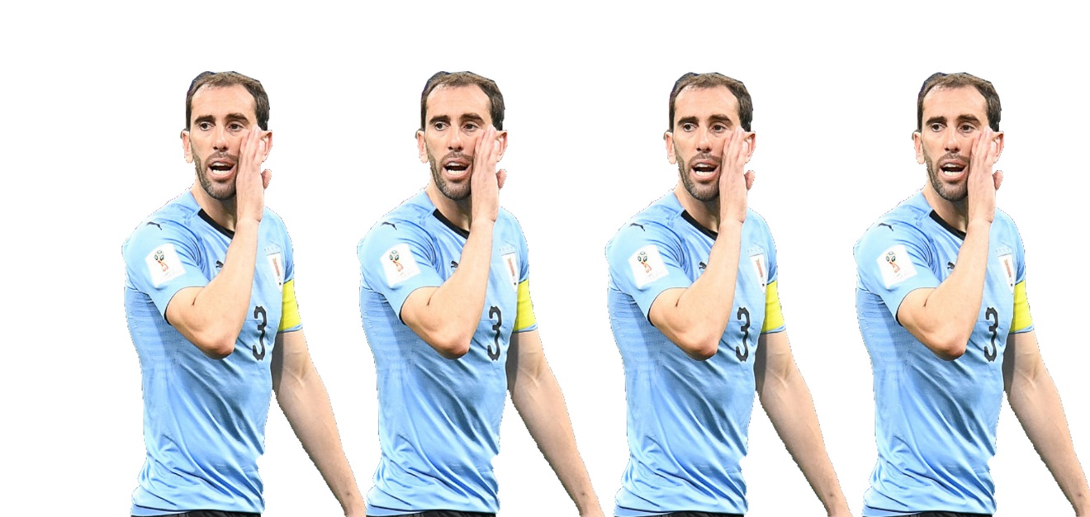

K) Pick a picture of a dromedary perform puppet warp to distort the pose of animal: bending, twist, (at least 8 poses)

**ANSWER**

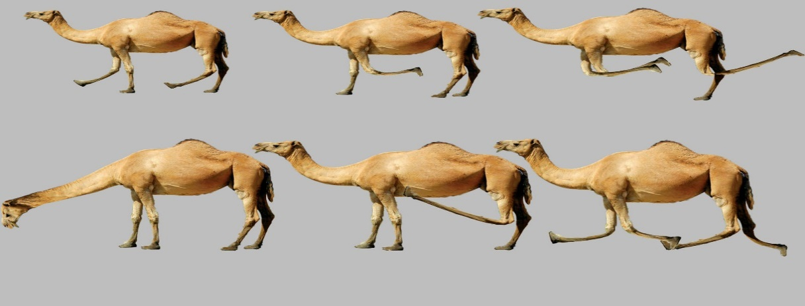

l) Pick a picture of two players Ronaldinho and Zinedine Zidane and perform face swapping.